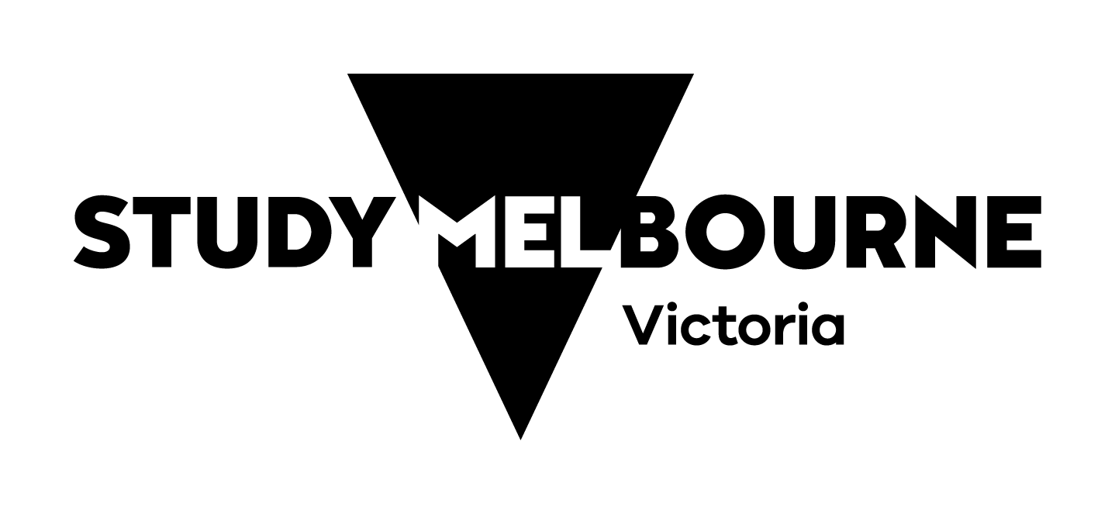

Study with Victoria

A strategy for Victoria’s international education sector, enabling students to study with Victoria from anywhere in the world.

Vision:
Victoria is a global leader in education and student experience, recognised for quality, innovation, and inclusion.

Goals:
A leader in student experience and graduate outcomes.
Diversified and strengthened global partnerships.
A global reputation for education excellence.

Pillars:
The student experience
Actions:
Provide accessible support services through the Study Melbourne Hub.
Provide free and confidential legal support for employment and accommodation matters.
Support inclusive industry and student led projects (Study Melbourne Inclusion Program).
Improve affordability and access through the International Student Travel Pass.
Foster school-sector student support and voice.
Employability and alumni connections
Actions:
Deliver student programs that foster employability and entrepreneurship.
Elevate leadership capability and talent through Study Melbourne Ambassadors.
Promote post‑study pathways.
Strengthen alumni engagement.
Promotion of Victoria’s education offering
Actions:
Promote Study Melbourne Brand.
Grow Study Melbourne digital ecosystem.
Showcase regional Victoria.
Celebrate excellence through Victoria’s International Education Awards.
Global connections and partnerships
Actions:
Champion Victoria offshore through the Global Education Network.
Support the expansion of transnational education delivery and partnerships.
Promote digital learning and education innovation.
Collaboration for a strong sector
Actions:
Drive industry engagement.
Embed meaningful student engagement.
Lead regular forums to improve student experience.
Collaborate with the City of Melbourne.
Advocate on behalf of the sector and students to the Australian Government.
The Victorian Government, through Study Melbourne, monitors the outcomes of Study with Victoria through 7 measures of success. Visit the Study Melbourne website to learn more and see our progress.

